Using SPSS

1. Open SPSS:
   1. Windows: Start > All programs > IBM (usually) > SPSS XX (20-22 currently).
   2. Mac: Finder > Applications > IBM > SPSS > Statistics > XX
   3. Note: Some older versions (16-18) are called PASW
   4. You can just hit cancel if you get this window.
   5. Sometimes data does not open right the first time, so you might have to double click the data to open again (if you started by trying to open data).

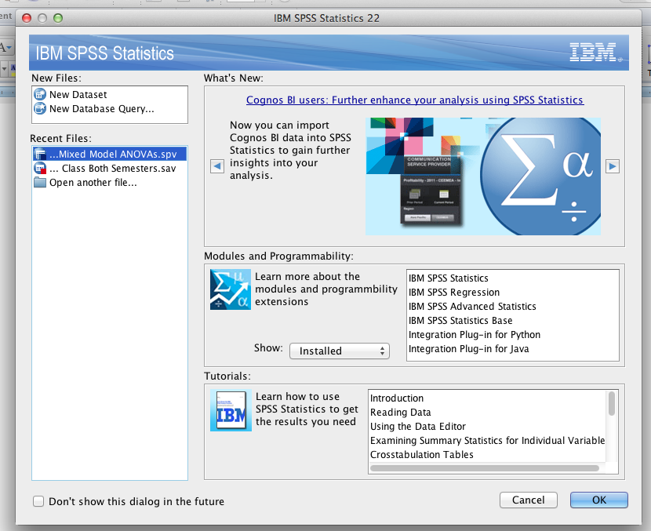

*Note.* Demos are from SPSS Mac Version 22 – the options and drop down boxes are the same as Windows versions.

1. Opening files
   1. File > Open > Data
   2. .sav files are data files.
   3. .sps files are syntax files.
   4. .spv are output files.

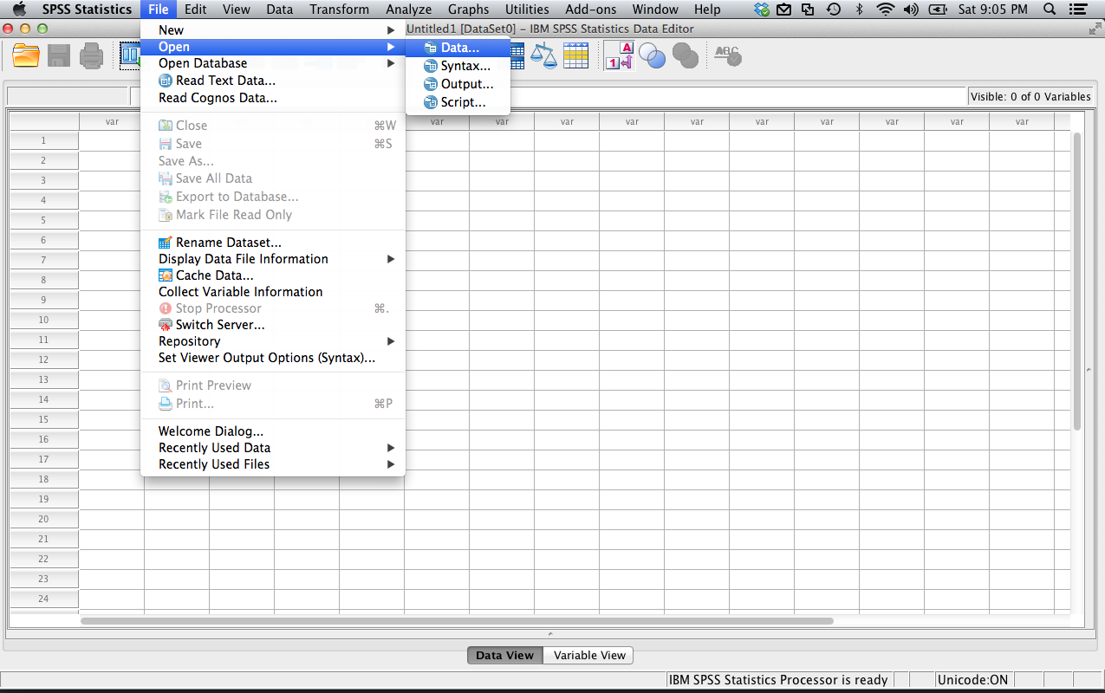

1. File set up: two ways to view the data:
   1. Data view:
      1. Columns = variables
      2. Rows = people – each person gets their own row
      3. Example
         1. Gives you the place to enter scores from participants
         2. As well as group labels for experimental designs (see last column)
      4. Looks a lot like excel
         1. Except that you can label the variables at the top instead of in the first row
         2. Do not enter text unless you want the column to be a text column (then numbers don’t act like numbers … if it doesn’t have decimals, it’s probably listed as text).

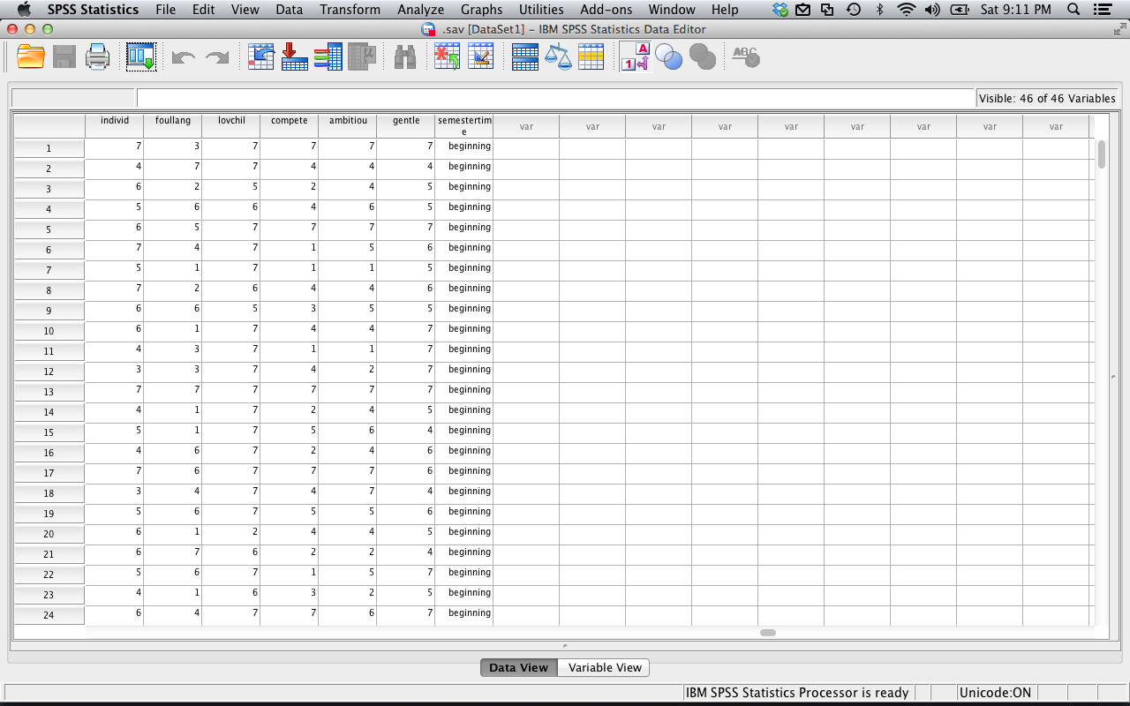

* 1. Variable view:
     1. Has the list of variables (one for each row)
     2. These will be the columns across the top
     3. You cannot use symbols, start with numbers, or use spaces
     4. Type column
        1. If you want to put letters into a column, be sure the type column is “string” or it won’t work.
        2. Also! If you label a column as string and then try to use it in analyses, it will tell you politely that you are dumb.
     5. Label column
        1. Use this column to describe the variable in more descriptive terms
        2. Great for making charts
        3. Helps you remember what you did months later when you are trying to reanalyze the data.

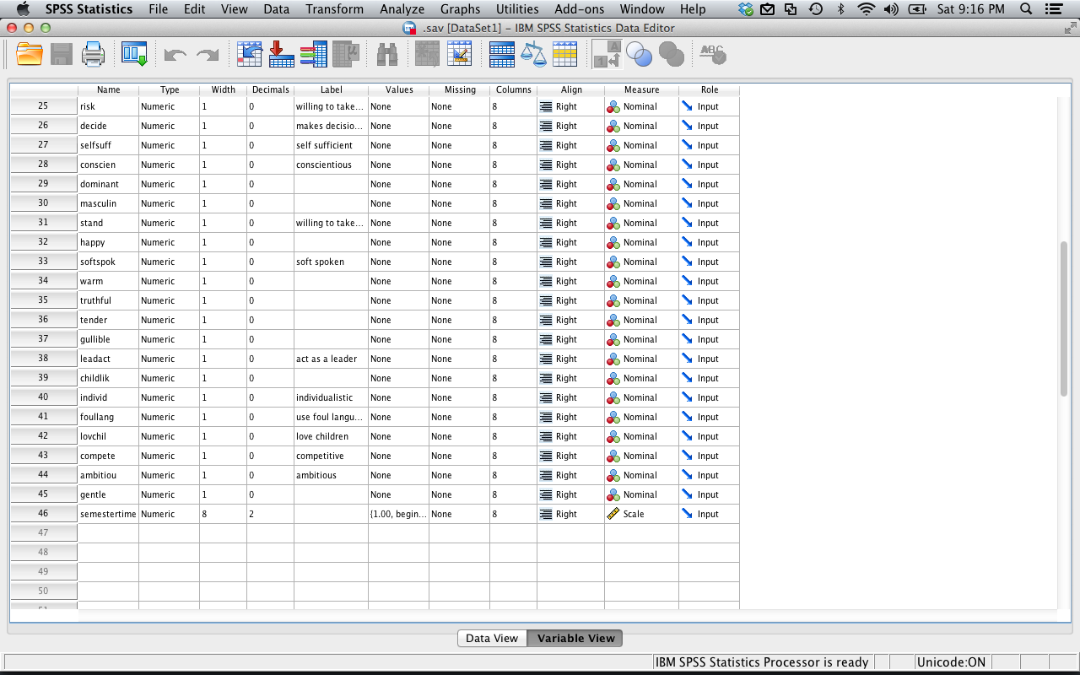

* + 1. Values column
       1. Click on the little box next to values for the rowid variable.
       2. Now you’ll see a bunch of numbers with corresponding strings
       3. This is a way to label your groups
    2. If you can’t see the values you’ve given something when looking at data view
       1. View > value labels

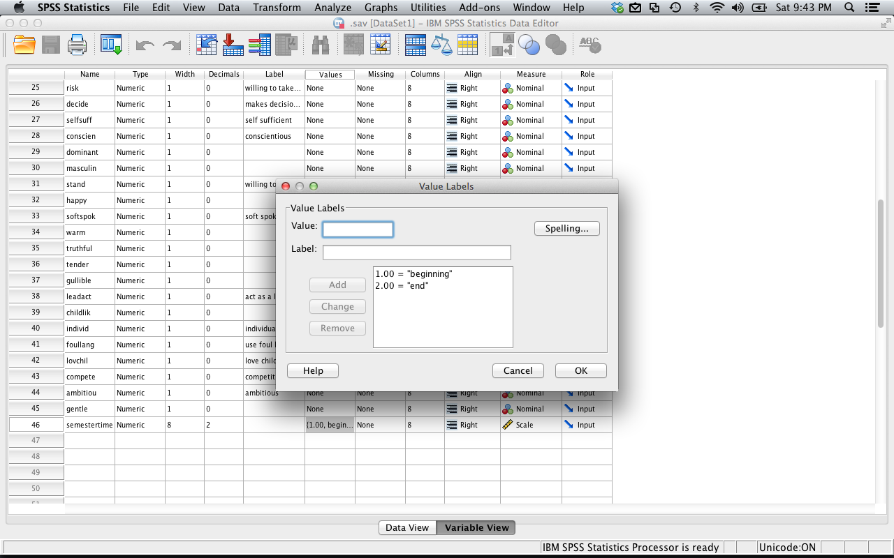

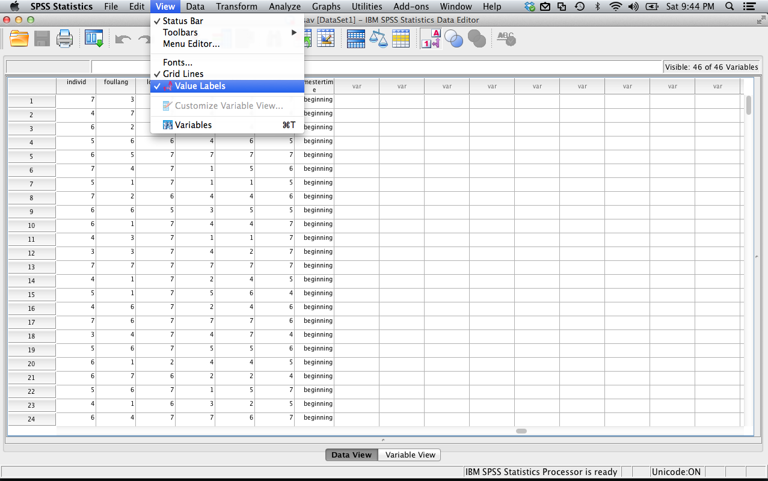

* 1. If you want a new variable, you can just start typing in a new column (in either data or variable view).
     1. It will label the variable for you as “var00001” or something similar.
     2. If you want to give it a name, click variable view, and you can relabel it.
  2. If you want to add new people
     1. Just start typing in data in a new row.
     2. Note: if you have a column with value labels, then you’ll need to stick with the same numbering system
     3. If you give it a number it doesn’t recognize, it’ll show up as that number.

1. Data Drop Down
   1. The data option lets you find data you need quickly, or sort cases
   2. Sort cases – let’s you sort your data (helpful for outlier analyses)
   3. Split file – let’s you run an analysis separate for each group (helpful for data screening).
   4. Select cases – let’s you pick only a subset of the data (i.e. high values, specific values, etc.).

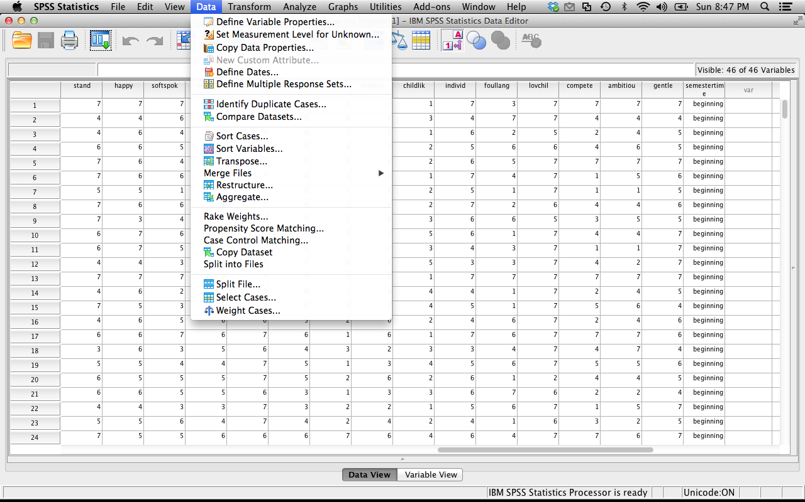

1. Transform Drop Down
   1. Transform lets you change variables without having to start over
   2. You can create new variables that are functions of old variables (i.e. average two columns, add up four columns, create an interaction term).
   3. Compute – let’s you create averages, create random variables
   4. Recode into same variables – let’s you recode values in the same column (helpful for reverse coding Likert scale items)
   5. Recode into different variables – let’s you recode values into different columns (helpful for creating new groups, but you don’t want to lose the old column – like control group versus all three experimental groups).

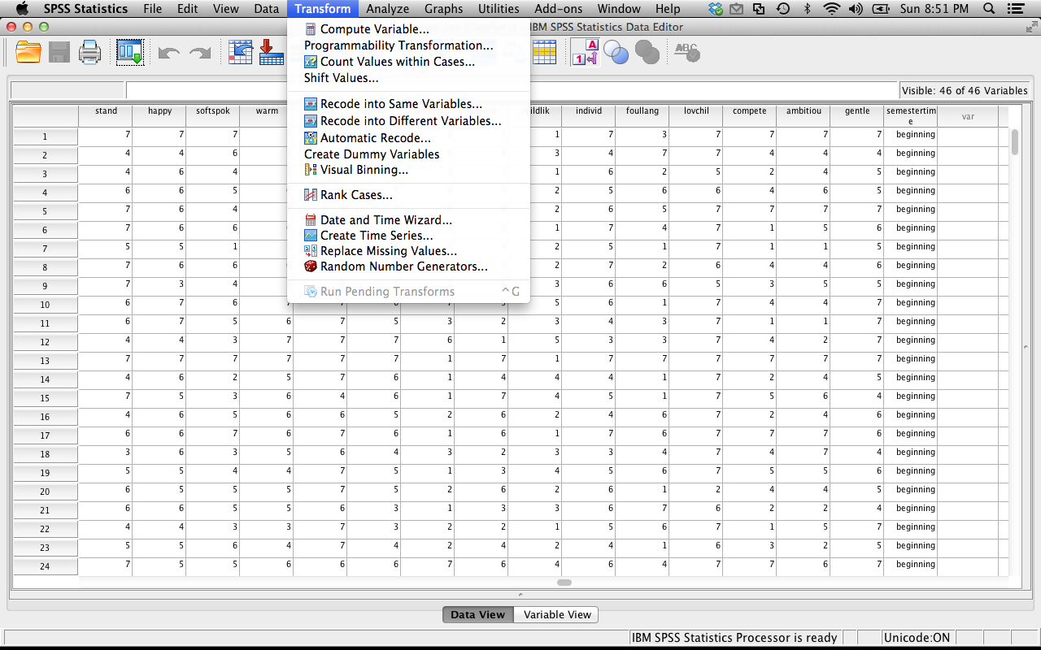

1. Analyze Drop Down
   1. This window is the most important!
      1. We will go through how to run each test when we cover that test.
   2. If you are running a statistical test, it will be under Analyze.

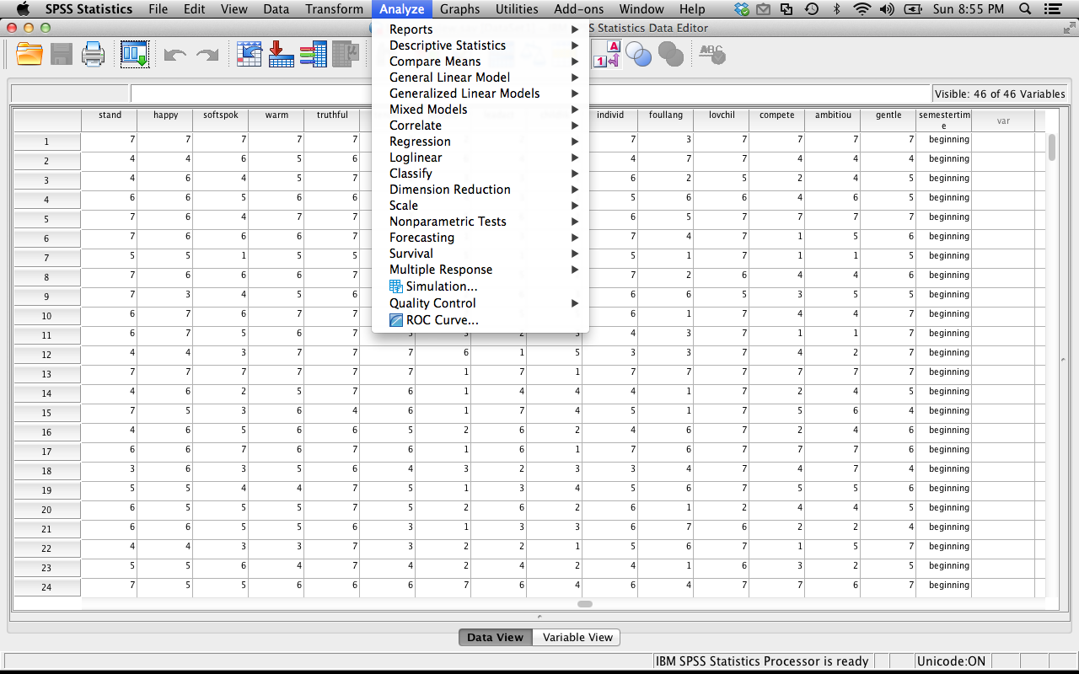

1. Chart builder
   1. Let’s you create scatter plots, histograms, line, and bar graphs.
   2. We will do a big section on chart builder! This section is why labels are important – they are used for the x-y axis labels on graphs.

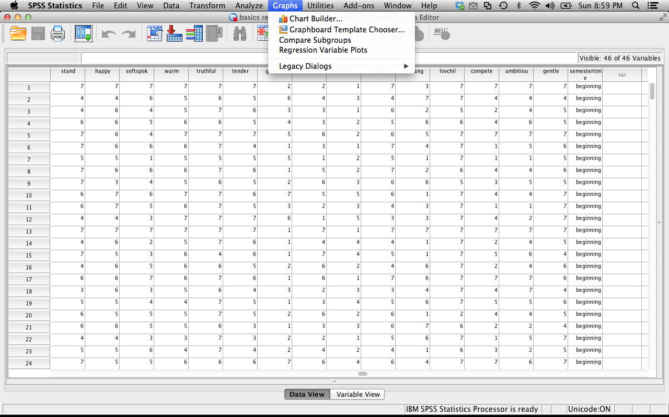

1. Entering data
   1. Each person should get their own row.
      1. For dependent data, or when you took several variables from the same person, each person will have several columns of data.
   2. Each variable should get its own column.
   3. You have to enter group information into its own column – make up labels for them but they *need* to be numbers (1, 2, 875, doesn’t matter).
   4. You can use value labels to give them names (see above).